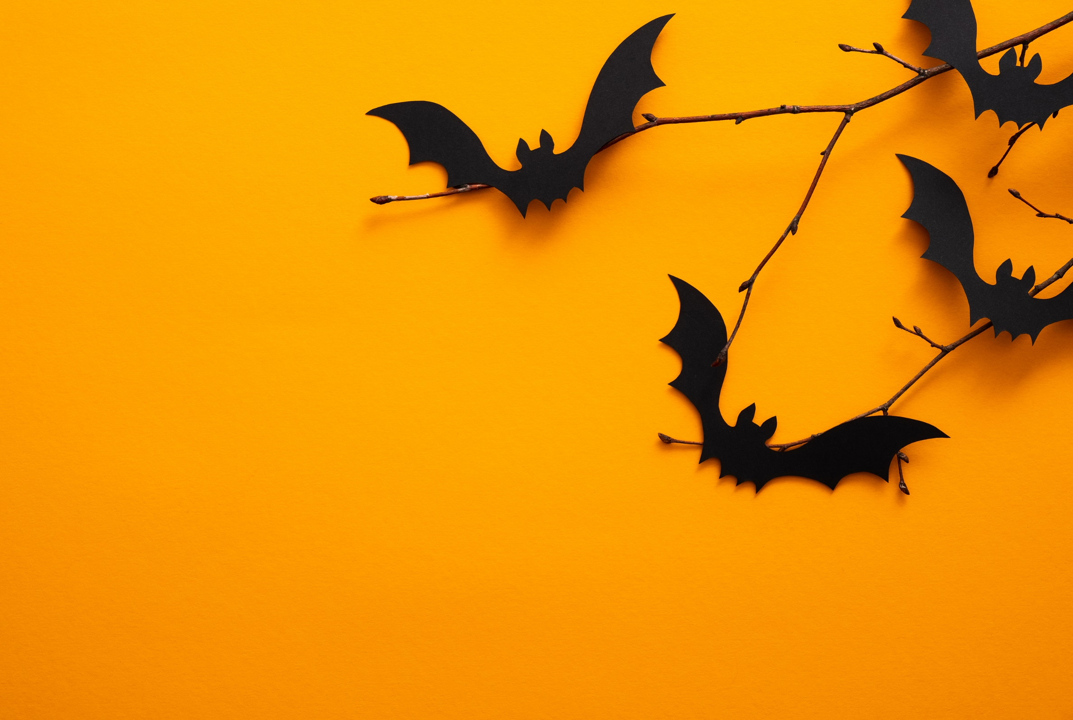

**Halloween Disco**

**Friday 14th October**

**Ticket Price £3** (includes a bag of sweets &

unlimited drinks)

**Please send payment to school in a named envelope or tickets can be bought on the door**

**Reception, Yr 1, 2 & 3** – **5:30pm to 6:30pm**

**Yr 3,4,5 & 6** – **6:45pm to 8pm**

Year 3 can choose which disco to attend

**Glow sticks** will be available to purchase on the night for **50p**