Mastering Number at Home
Reception – Week 1
Play ‘Subitising to 3 Snap’  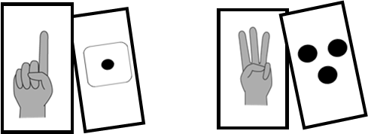  (Monday, Wednesday and Friday)  How to play  - Cut out the subitising cards on the worksheet ‘Subitising to 3 Snap’.  - Place the cards face-down on a flat surface.  - Take it in turns to turn over 2 cards at a time. Say the numbers you see on each card.  - If the numbers are the same, the player taking the turn wins the cards. If the numbers are different, the player must turn the cards face-down again.  - The winner is the player with the most cards at the end of the game. | Play the ‘Part–part–whole game’  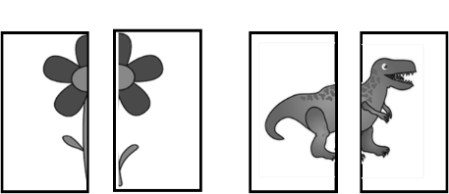  (Tuesday and Thursday)  How to play  - Cut out the image cards on the worksheet ‘Part–part–whole game’.  - Place the cards face-up on a flat surface.  - Take it in turns to pick 2 cards that make a whole.  - Say, “part, part”, as you pick up the cards, and “whole” as you put them together to make the complete image.
Other things to try at home

Hiding games
Hide up to 3 objects, such as acorns, blocks or small toys, under a tea towel, or under your hand. Quickly reveal the objects, then hide them again, saying, “How many?” Can your child subitise the amount without counting?

Be ‘2-spotters’
Ask your child to spot things at home that there are 2 of. Some things are often found in 2s, such as shoes or socks, but we can have 2 of anything!




