Mastering Number at Home
Year 1 – Week 1
Drop the counters  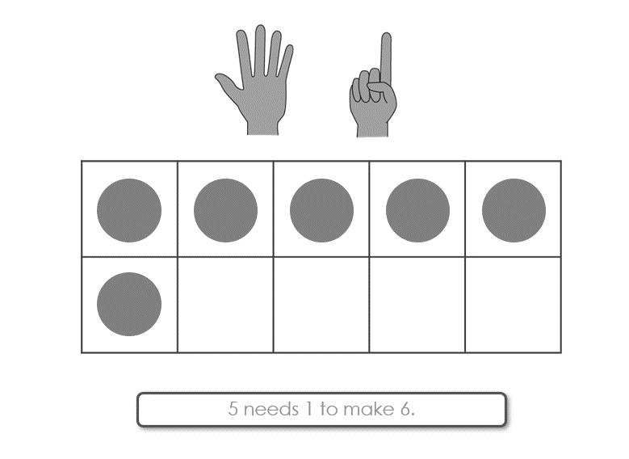  6 is made of 4 and 2.  4 and 2 make 6.  (Monday, Wednesday and Friday)  How to play  - For this game, you will need 6 two-colour counters and the worksheet ‘Drop the counters’. Decide who will be player 1 and who will be player 2.  - Take it in turns to hold 6 counters in your hand and to drop them all at once onto the table.  - Check how many of each colour are showing. [Note that if all the counters land with the same colour showing, the player misses their turn.]  - Use the stem sentence to say aloud the way you have made 6. [See the example above and the worksheet ‘Stem sentences’ for guidance.]  - On your recording sheet, cross out the way you have made 6 with the counters.  - Keep playing until either player has crossed out all the ways to make 6 on their sheet. | Egg box 6  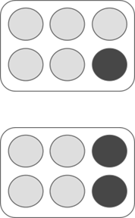  6 is made of 5 and 1.  5 and 1 make 6.  6 is made of 4 and 2.  4 and 2 make 6.  (Tuesday and Thursday)  How to play  - For this game you will need an egg box and 6 two-colour counters.  - Place all 6 counters in the empty spaces in the egg box, with the same colour facing up.  - Turn over 1 counter and use the stem sentence to say the way to make 6 that is shown – “6 is made of 5 and 1…” [See the example above and the worksheet ‘Stem sentences’ for guidance.]  - Keep turning over 1 counter at a time and saying the new way to make 6 until you have found all of the ways to make 6.
Other things to try at home
Noticing packs of 6
In your home, can you make a list of things you have bought in packs of 6?

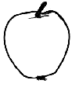
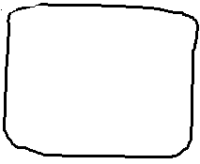


Things to try outdoors
Make sets of 6 things you can find in nature, e.g. 6 leaves, 6 acorns, 6 conkers, 6 twigs, and so on. If you see a collection of fewer than 6 things, ask, “How many more will make 6?”

