Mastering Number at Home
Year 2 – Week 1
Copy my number  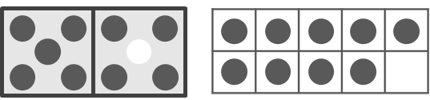  (Monday, Wednesday and Friday)  How to play  - For this game, you will need the ‘Double dice frame and 10-frame’ worksheet and 20 counters.  - Cut out both frames.  - Place some counters on the double dice frame to make a number larger than 5 (note that you should fill the left-hand side of the frame before adding counters to the right-hand side).  - Ask your child to make the same number on the 10-frame, ensuring they start with 5 counters on the top row each time.  - Repeat this activity several times. [If your child finds this easy, you may wish to cover the double dice frame with a cloth and reveal the number of counters only briefly.] | 7 or NOT 7?  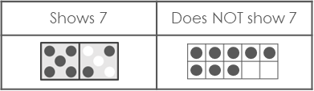  (Tuesday and Thursday)  How to play  - For this game, you will need the ‘5-and-a-bit cards’ and ‘Sorting table’ worksheets.  - Cut out the cards and place them face-down on a flat surface.  - Take it in turns to pick up 1 card.  - If the arrangement on the card shows 7, place it in the ‘Shows 7’ column of the sorting table. If it does not show 7, place it in the ‘Does NOT show 7’ column.  - Ask your child to tell you how they know if the card is in the correct column. For example, “7 is made of 5 and 2, and this card is 5 and 3”.
Other things to try at home

Match my fingers

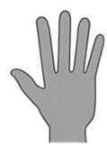
For this game, you will need the cards you cut from the worksheet ‘5-and-a-bit cards’. Spread out the cards face-up on a flat surface.
Use the fingers of both hands to show your child a number that is more than 5. Make sure you show 5 fingers on one hand and the remaining fingers on the other hand.
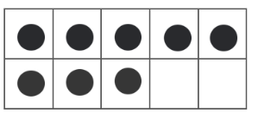

Ask your child to find ALL the cards that show the number represented by your fingers.

