Mastering Number at Home
Reception – Week 2
Play ‘3 frogs on a log’  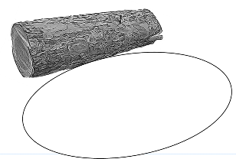  (Monday, Wednesday and Friday)  How to play  - For this game, you will need the worksheet ‘Frogs on a log’ and 3 counters or similar small objects to represent the frogs. You may wish to make your own frogs (see ‘Other things to try at home’ below).  - Use 3 counters/frogs each time. Put some on the log and some in the pond.  - Ask your child to show with their fingers: “How many are on the log?” / “How many are in the pond?” / “How many are there altogether?” | Play ‘3 or NOT 3?’  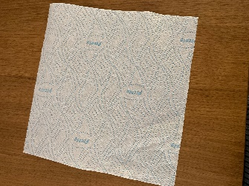  (Tuesday and Thursday)  How to play  - Find up to 5 small objects (such as acorns, blocks or marbles) and a tea towel or cloth.  - Hide some of the 5 objects under the cloth and then briefly reveal them (for 1–2 seconds).  - Ask your child, “Is it 3 or NOT 3?”  - Try this with different numbers of objects up to 5.  - After a few rounds of the game, if the number of objects is NOT 3, ask your child, “How can we make it into 3?”
Other things to try at home

Make your own frogs
Ask your child to draw 4 frogs on the inside of a cereal box and then to colour them in. Once complete, cut out the frogs and use them to play ‘3 frogs on a log’ instead of the counters or similar small objects. [Note that the extra frog will not be used until Week 4.]

Be ‘3-spotters’
Ask your child to spot things that are in 3s when you go for a walk; for example, 3 parked cars in a row.

