Mastering Number at Home
Year 1 – Week 3
Find pairs to 6 (with numbers)  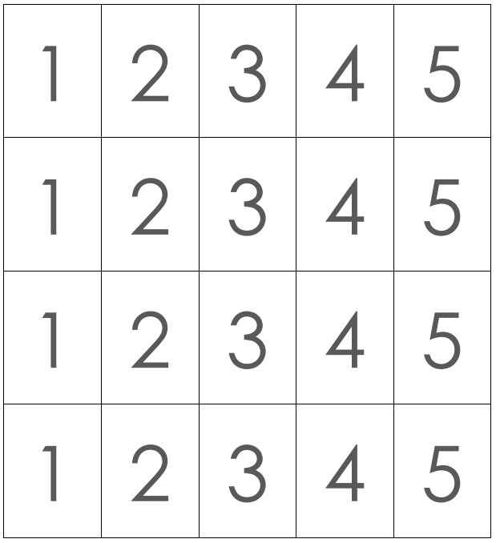  (Monday, Wednesday and Friday)  How to play  - Cut out the number cards on the worksheet ‘Find pairs to 6 (with numbers)’.  - Place the cards face-up on a flat surface.  - Pick up 1 card. Can your child find its partner so the 2 cards together make 6 (e.g. 5 and 1, 4 and 2, etc.)?  - Repeat with different cards, so your child can practise finding all the ways to make 6.  - On Friday, you may wish to time your child to see how quickly they can find all the ways to make 6. | Copy my 7    (Tuesday and Thursday)  How to play  - For this game you will need BOTH frames from the worksheet ‘Double dice frames’ and 14 two-colour counters (e.g. red on 1 side, yellow on the other).  - Place the 2 double dice frames side by side, and take 7 counters each.  - Ask your child to cover their eyes, then place 7 counters on your frame, with some counters red side up and some yellow side up. Make sure the red counters are placed close together and the yellow counters are placed close together.  - Briefly reveal the frame. Can your child show 7 on their frame in the same way? Use the stem sentence to describe how 7 has been made, e.g. “7 is made of 5 and 2…” [See the worksheet ‘Stem sentences’ for guidance.]  - Swap roles and ask your child to create their own arrangement of 7 counters for you to copy. Repeat the stem sentence as before.
Other things to try at home

Other activities with dice frames

How many ways can your child make 7 by placing counters on the double dice frame? Encourage them to describe what they see – it might not be how you see it! You can use a combination of 2 different coloured counters, or just 1 colour.

