Mastering Number at Home
Reception – Week 4
Play ‘4 frogs on a log’  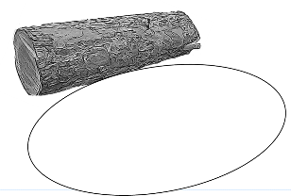  (Monday, Wednesday and Friday)  How to play  - For this game, you will need the worksheet ‘Frogs on a log’ and 4 counters or similar small objects to represent the frogs. [If you made your own frogs in Week 2, you can use them here instead of the counters.]  - Use 4 counters/frogs each time. Put some on the log and some in the pond.  - Ask your child to show with their fingers: “How many are on the log?” / “How many are in the pond?” / “How many are there altogether?” | Play ‘4 or NOT 4?’  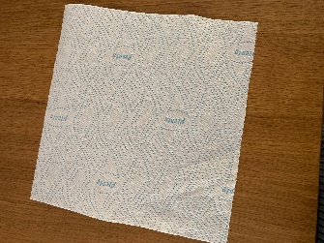  (Tuesday and Thursday)  How to play  - Find up to 6 small objects (such as acorns, blocks or marbles) and a tea towel or cloth.  - Hide some of the 6 objects under the cloth and then briefly reveal them (for 1–2 seconds).  - Ask your child, “Is it 4 or NOT 4?”  - Try this with different numbers of objects up to 6.  - After a few rounds of the game, if the number of objects is NOT 4, ask your child, “How can we make it into 4?”
Other things to try at home

Notice 4 while out and about
While out walking, perhaps on your way to school, ask your child to spot things that are in a group of 4; for example, 4 flowers growing at the side of the road.




If there are not 4, you might ask your child, “How many more will make 4?”

