Mastering Number at Home
Year 1 – Week 4
Find pairs to 7 (with dots)  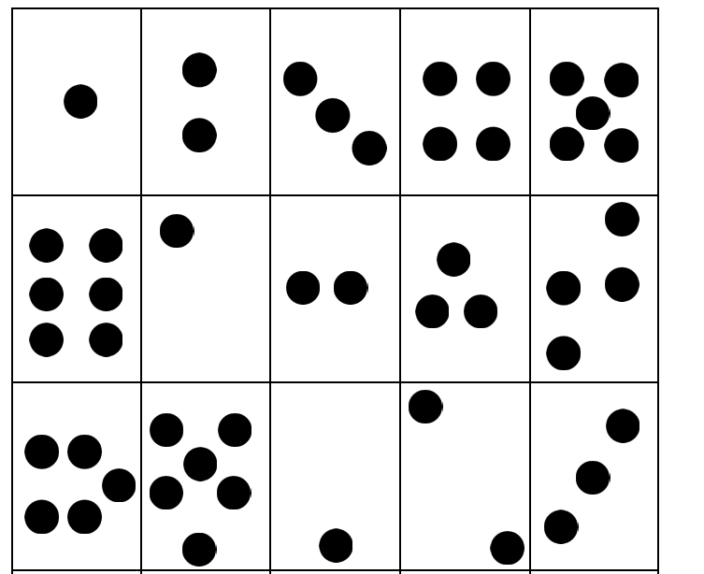  (Monday, Wednesday and Friday)  How to play  - Cut out the cards on the worksheet ‘Find pairs to 7 (with dots)’ and place them face-up on a flat surface.  - Pick up 1 card. Can your child find its partner, so the 2 cards together make 7?  - [Note: Your child should not rely on COUNTING the dots, but on recognising the ‘parts’ of 7.]  - On Friday, you may wish to time your child to see how quickly they can find all the ways to make 7. | Make it 7    (Tuesday and Thursday)  How to play  - For this game you will need ONE of the frames from the worksheet ‘Double dice frames’ and 10 counters.  - Place some of the counters on 1 side of the frame.  - Ask your child to place counters on the other side of the frame to make 7 altogether.  - Play the game several times.  - For a greater challenge, remove the frame and arrange the counters randomly on a flat surface. Can your child still make 7 without counting?

Other things to try at home

Hide the coins
For this game you will need 7 one-penny coins. Split the coins between your 2 hands and close your fists around them. Reveal the coins in 1 hand to your child. Can they say how many coins are in the other hand to make 7 altogether?

Heads and tails
Explain the concept of ‘heads’ and ‘tails’ to your child using a one-penny coin. Then, drop 7 one-penny coins onto a flat surface. Ask your child, “How many coins are showing heads? How many are showing tails?” Can your child tell you the answer without counting them?
Finally, say what you can see, e.g. “5 heads and 2 tails is 7 altogether.”

