Mastering Number at Home
Year 2 – Week 4
Explore odd and even numbers  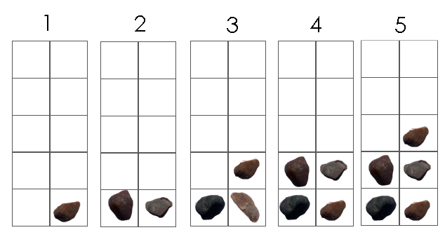  (Monday, Wednesday and Friday)  How to play  - For this game, you will need the ‘Small 10-frames’ worksheet and 55 small objects from home, such as pebbles or dried beans.  - Say a number from 1 to 10 and ask your child to pick up that number of objects and place them on the correct 10-frame. (For example, if you say “4”, they should place 4 objects in the 10-frame labelled ‘4’.)  - Ask your child to look at whether there is an ‘odd one’ to help them say whether the number they have made is odd or even.  - Repeat the activity with the other numbers between 1 and 10. Can your child begin to say whether the number will be odd or even BEFORE they make it? | 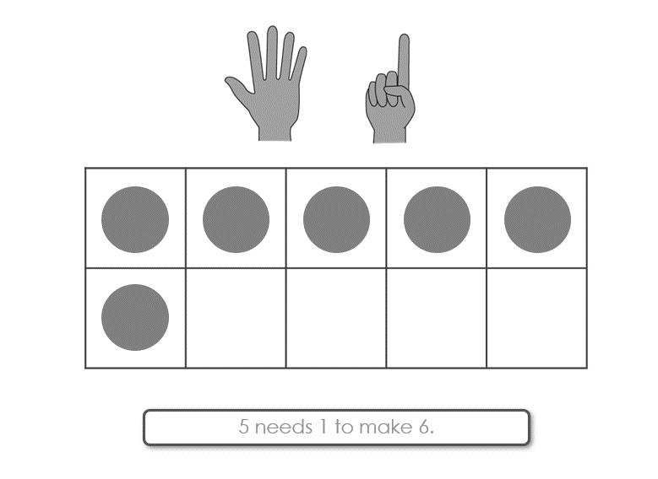  Odd and even parts of 10  I can see 4 and 6.  They’re both even numbers!  (Tuesday and Thursday)  How to play  - For this game, you will need 10 two-colour counters.  - Drop the counters onto a flat surface.  - Ask your child to arrange the counters into two groups – one for each colour. Can they say how many are in each group without counting?  - Ask your child to say if the two parts of 10 they can see are odd or even.  - Swap roles and repeat the activity.  - To challenge your child, see if they are able to recognise whether the parts are odd or even without grouping the colours together first.
Other things to try at home
Is it 7 or 8?
Collect 8 similar small objects (for example, buttons, blocks or toy cars) and a cloth to cover them. Hide either 7 or all 8 of the objects under the cloth. (If you choose 7, you will need to secretly hide 1 of the objects in your hand.) Reveal the objects briefly, then cover them back up. Can your child say whether there are 7 or 8 objects without counting?

Take it in turns to hide the objects, randomly choosing to hide 7 or 8 of them each time. Can either of you think of ways to arrange the objects that will make it easier or harder for the other person to see which number is shown?

Look out for odds and evens!
Throughout your day, help your child to look out for instances in which a set of objects (for example, socks, toys or snacks) can be put into pairs, or where there is an ‘odd one’.

