Mastering Number at Home
Year 1 – Week 5
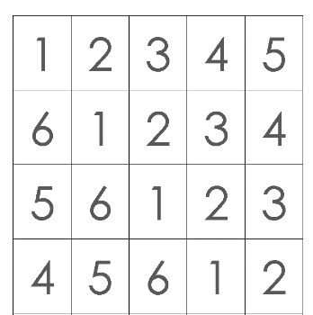  Find pairs to 7 (with numbers)  (Monday, Wednesday and Friday)  How to play  - Cut out the number cards on the worksheet ‘Find pairs to 7 (with numbers)’ and place them face-up on a flat surface.  - Pick up 1 card. Can your child find its partner, so the 2 cards together make 7?  - Repeat with different cards, so your child can practise finding all the ways to make 7.  - On Friday, you may wish to time your child to see how quickly they can find all the ways to make 7. | Is it 6 or 7?    (Tuesday and Thursday)  How to play  - For this game you will need the ‘Double dice frames’ worksheet and 7 counters.  - Place either 6 or 7 counters in the spaces on ONE of the dice frames, then hide the frame with a cloth or a tea towel.  - Briefly reveal the counters and ask your child, “Is it 6 or 7?” Can they answer without counting?  - Think about how you could arrange the counters to make it more difficult. (You could start by always filling the first 5 spaces so your child can see ‘5 and 1’ and ‘5 and 2’. Then you could explore using ANY of the spaces in the frame so that, e.g. 6 could be ‘4 and 2’ or ‘3 and 3’.)  - Take it in turns to position and hide the counters, making arrangements of either 6 or 7 each time.
Other things to try at home
Play variations of ‘6 or 7?’
Gather 7 similar small objects from around your home, e.g. 7 blocks, 7 buttons, 7 toy cars, etc. You will also need a tea towel or cloth to cover the objects.

Place either 6 or 7 objects under the cloth, arranged in 2 clear groups. Reveal the arrangement briefly and ask your child, “Is it 6 or 7?” Can they tell you without counting? After 5 turns (rearranging the objects each time), swap roles so your child hides the objects.

Is it 6 or 7?
How do you know?

